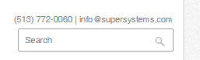 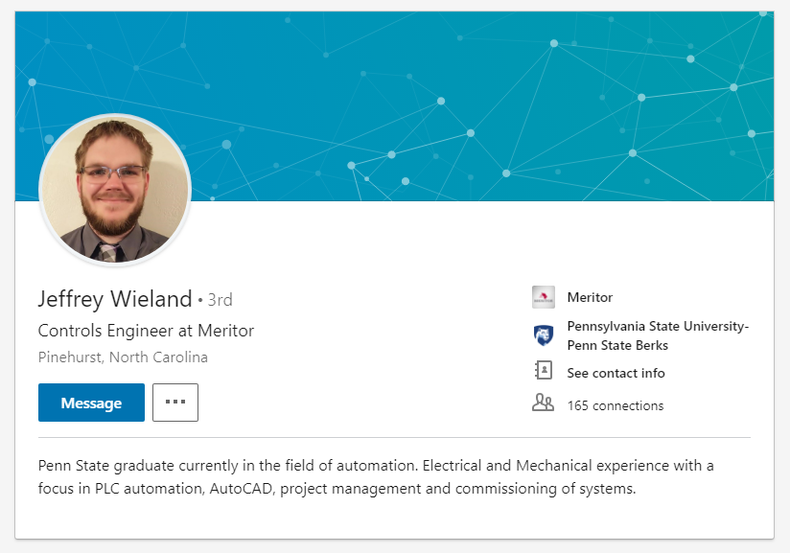



 7205 Edington Drive, Cincinnati OH 45249

It’s a controls engineer job and they don’t offer sponsorship/ Super Systems .

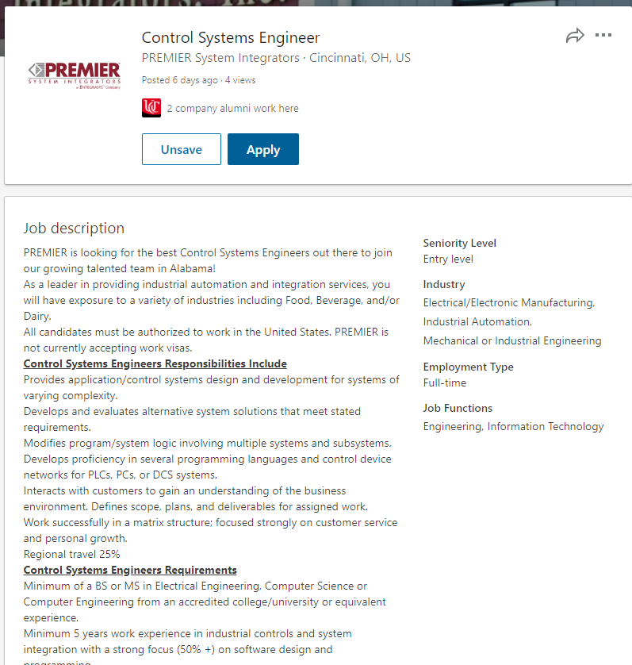

Call them and explain no sponsorship needed and say if they can give a chance.

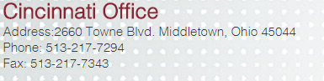

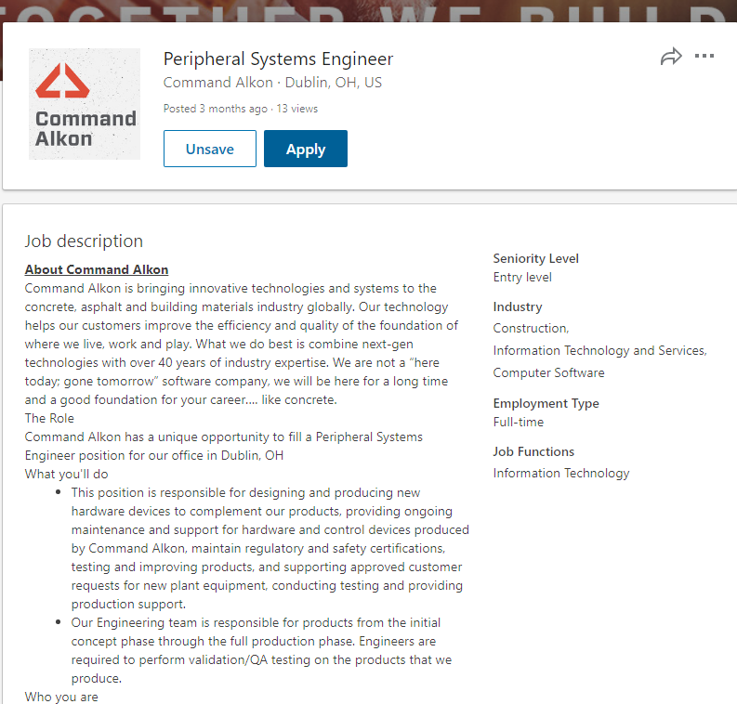

Call them and check if job still available. Talk about software stuuf.

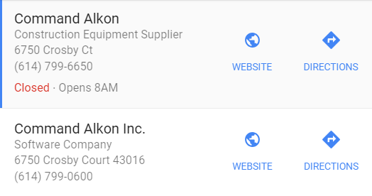

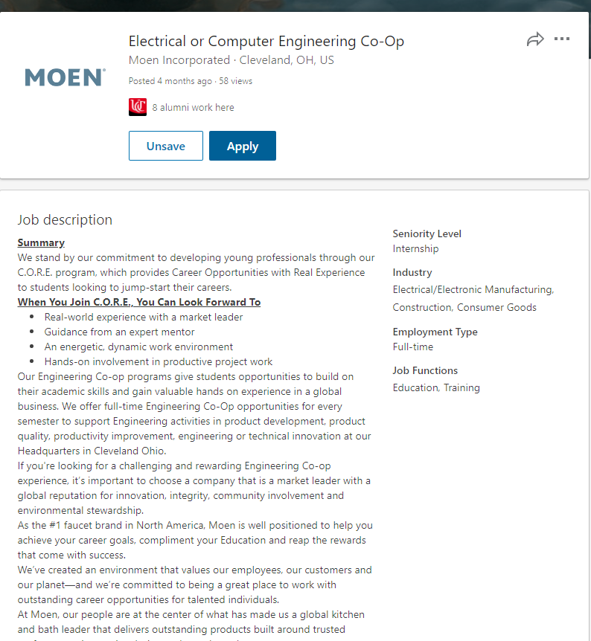

Posted 4 months ago check if still available and sell.

Left a message for Blake. 4409622000



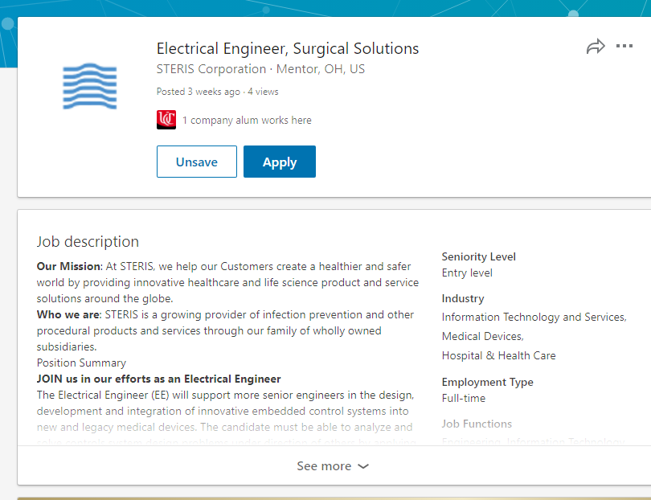

Call since no one applied:

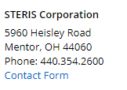

Try to find information on linkedin to contact recruiter

Need toi start from here

